- Study About Moleculer Architecture in deep about how it works and apart from above features whatother features it can offer for an api.

* What is Moleculer ?
-> Moleculer is a fast, modern and powerful microservices framework for Node.js. It helps you to build efficient, reliable & scalable services. Moleculer provides many features for building and managing your microservices.

* Features

- request-reply concept
- Promise-based Solution(async/ Await Compatible)
- support event driven architecture with balancing
- built-in service registry & dynamic service discovery
- load balanced requests & events (round-robin, random, cpu-usage, latency, sharding)
- many fault tolerance features (Circuit Breaker, Bulkhead, Retry, Timeout, Fallback)
- plugin/middleware system
- support versioned services
- support Streams
- service mixins
- built-in caching solution (Memory, MemoryLRU, Redis)
- pluggable loggers (Console, File, Pino, Bunyan, Winston, Debug, Datadog, Log4js)
- pluggable transporters (TCP, NATS, MQTT, Redis, NATS Streaming, Kafka, AMQP 0.9, AMQP 1.0)
- pluggable serializers (JSON, Avro, MsgPack, Protocol Buffer, Thrift)
- pluggable parameter validator
- multiple services on a node/server
- master-less architecture, all nodes are equal
- parameter validation with fastest-validator
- built-in metrics feature with reporters (Console, CSV, Datadog, Event, Prometheus, StatsD)
- built-in tracing feature with exporters (Console, Datadog, Event, Jaeger, Zipkin)
- official API gateway, Database access and many other modules…

Architecture

From the architectural point-of-view the online store can be seen as a composition of 2 independent services: the products service and the gateway service. The first one is responsible for storage and management of the products while the second simply receives user´s requests and conveys them to the products service.

Now let’s take a look at how this hypothetical store can be created with Moleculer.
To ensure that our system is resilient to failures we will run the products and the gateway services in dedicated nodes (node-1 and node-2). If you recall, running services at dedicated nodes means that the transporter module is required for inter services communication. Most of the transporters supported by Moleculer rely on a message broker for inter services communication, so we’re going to need one up and running. Overall, the internal architecture of our store is represented in the figure below.

Now, assuming that our services are up and running, the online store can serve user’s requests. So let’s see what actually happens with a request to list all available products. First, the request (GET /products) is received by the HTTP server running at node-1. The incoming request is simply passed from the HTTP server to the gateway service that does all the processing and mapping. In this case in particular, the user´s request is mapped into a listProducts action of the products service. Next, the request is passed to the broker, which checks whether the products service is a local or a remote service. In this case, the products service is remote so the broker needs to use the transporter module to deliver the request. The transporter simply grabs the request and sends it through the communication bus. Since both nodes (node-1 and node-2) are connected to the same communication bus (message broker), the request is successfully delivered to the node-2. Upon reception, the broker of node-2 will parse the incoming request and forward it to the products service. Finally, the products service invokes the listProducts action and returns the list of all available products. The response is simply forwarded back to the end-user.

Flow of user’s request

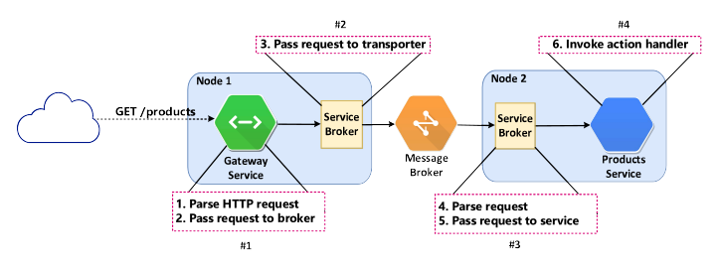
All the details that we’ve just seen might seem scary and complicated but you don’t need to be afraid. Moleculer does all the heavy lifting for you! You (the developer) only need to focus on the application logic.

Other Features that Moleculer Provides
- Action hooks : Action hooks are pluggable and reusable middleware functions that can be registered before, after or on errors of service actions. A hook is either a Function or a String. In case of a String it must be equal to service’s method name.
- Registry and Discovery : Moleculer framework has a built-in module responsible for node discovery and periodic heartbeat verification. The discovery is dynamic meaning that a node don’t need to know anything about other nodes during start time. When it starts, it will announce it’s presence to all the other nodes so that each one can build its own local service registry. In case of a node crash (or stop) other nodes will detect it and remove the affected services from their registry. This way the following requests will be routed to live nodes.
- Fault Tolerance
- Caching : Moleculer has a built in caching solution to cache responses of service actions.
- Metrics : Moleculer has a built-in metrics module that collects a lot of internal moleculer & process metric values. Moreover, you can easily define your custom metrics. There are several built-in metrics reporters like console, Prometheus, Datadog, etc.
- Tracing : Moleculer has a built-in tracing module that collects tracing information inside a moleculer application. Moreover, you can easily create your custom tracing spans. There are several built-in tracing exporter like zipkin, jaeger, Datadog, etc

- Registering Service to a gateway
- The Moleculer-web is the official API gateway for Moleculer framework. Use it to publish your services as RESTful APIs.
- Install : npm i moleculer-web
- Run with default settings : This example uses API Gateway with default settings. You can access all services(including internal $node.) via http://localhost3000/

const {ServiceBroker} = require(“moleculer”);
const ApiService = require(“moleculer-web”);

const broker = new ServiceBroker();

// Load API Gateway
broker.createService(ApiService);

//Start Server
broker.start();

Example URLs:
call test.hello action : http://localhost:3000/test/hello
call math.add action with params : http://localhost:3000/math/add? a=25&b=13
get health of info of node : http://localhost:3000/~node/health
List all actions : http://localhost:3000/~node/actions

- WhiteList : If you dont want to publish all actions, you can filter them with whitelist option. Use match String or regexp in list. To enable all actions, use “**” item.

broker.createService({
mixins : [ApiService],

settings : {
routes : [{
path : “/api”,

whitelist : [

// Access any actions in ‘posts’ service
“posts.*”,
// Access call only the ‘users.list’ action
“users.list”,
// Acess any actions in ‘math’ service
/^math\.\w+$/
]
}]
}
});
- Aliases : You can use alise names instead of action names. You can also specify the method, Otherwise it will handle evry method types.

Using named parameters in aliases is possible. Named parameters are defined by prefixing a colon to parameter name (:name).

routes : [{
aliases : {
// call ‘auth.login’ action with ‘GET /login’ or ‘POST /login’
“login” : “auth.login”,
// Restrict the Request method
“POST users” : “users.create”,

// The ‘name’ comes from named param.
// you can access it with ‘ctx.params.name’ in action
“GET greeter/:name” : “test.greeter”,
},
}]

The Named Parameter is handled with path-to-regexp module. Therefore you can use optional and repeated parameters as well.

You can also create RESTful APIs. To use this alias, create service which has list, get, create, update, remove actions.
aliases : {
“GET users “ : “users.list”,
“GET users/:id” : “users.get”,
“POST users” : “users.create”,
“PUT users/:id” : “users.update”,
“DELETE users/:id” : “users.remove”
}

you can also use the simple shorthand alias :
aliases : {
“REST users” : “users”
}

- Mapping Policy : The route has a mapping policy property to handle route without aliases.

Available options :

all : enable to request all routes with or without aliases(default).
Restrict : enable to request only routes with aliases.

- Auto-alias : The auto-alias feature allows you to declare your route alias directly in your services. The gateway will dynamically build the full route from service schema.

Gateway will regenerate routes every time a service joins or leaves the network. Use whitelist parameter to specify services that the gateway should track and build routes.

Example:

// api.service.js
module.exports = {
mixins: [ApiGateway],
settings: {
routes: [
{
path: "/api",
whitelist: [
"posts.*",
"test.*"
],
aliases: {
"GET /hi": "test.hello"
},
autoAliases: true
}
]
}
};

// posts.service.js
module.exports = {
name: "posts",
version: 2,
settings: {
// Base path
rest: "posts/"
},
actions: {
list: {
// Expose as "/api/v2/posts/"
rest: "GET /",
handler(ctx) {}
},
get: {
// Expose as "/api/v2/posts/:id"
rest: "GET /:id",
handler(ctx) {}
},
create: {
rest: "POST /",
handler(ctx) {}
},
update: {
rest: "PUT /:id",
handler(ctx) {}
},
remove: {
rest: "DELETE /:id",
handler(ctx) {}
}
}
};

The generated aliases
GET /api/hi => test.hello
GET /api/v2/posts => v2.posts.list
GET /api/v2/posts/:id => v2.posts.get
POST /api/v2/posts => v2.posts.create
PUT /api/v2/posts/:id => v2.posts.update
DELETE /api/v2/posts/:id => v2.posts.remove

- Calling options : The route has a callOptions property which is passed to broker.call. So you can set timeout, retries , fallbackResponse opions for route.
- Cors Policy : You can use CORS headers in Moleculer-Web service.

settings: {
// Global CORS settings for all routes
cors: {
// Configures the Access-Control-Allow-Origin CORS header.
origin: "*",
// Configures the Access-Control-Allow-Methods CORS header.
methods: ["GET", "OPTIONS", "POST", "PUT", "DELETE"],

// Configures the Access-Control-Allow-Headers CORS header.
allowedHeaders: [],
// Configures the Access-Control-Expose-Headers CORS header.
exposedHeaders: [],
// Configures the Access-Control-Allow-Credentials CORS header.
credentials: false,
// Configures the Access-Control-Max-Age CORS header.
maxAge: 3600
},

- Circuit Breaker
- The Circuit Breaker can prevent an application from repeatedly trying to execute an operation that’s likely to fail. Allowing it to continue without waiting for the fault to be fixed or wasting CPU cycles while it determines that the fault is long lasting. The Circuit Breaker pattern also enables an application to detect whether the fault has been resolved. If the problem appears to have been fixed, the application can try to invoke the operation.
- The basic idea behind the circuit breaker is very simple. You wrap a protected function call in a circuit breaker object, which monitors for failures. Once the failures reach a certain threshold, the circuit breaker trips, and all further calls to the circuit breaker return with an error, without the protected call being made at all. Usually you'll also want some kind of monitor alert if the circuit breaker trips.

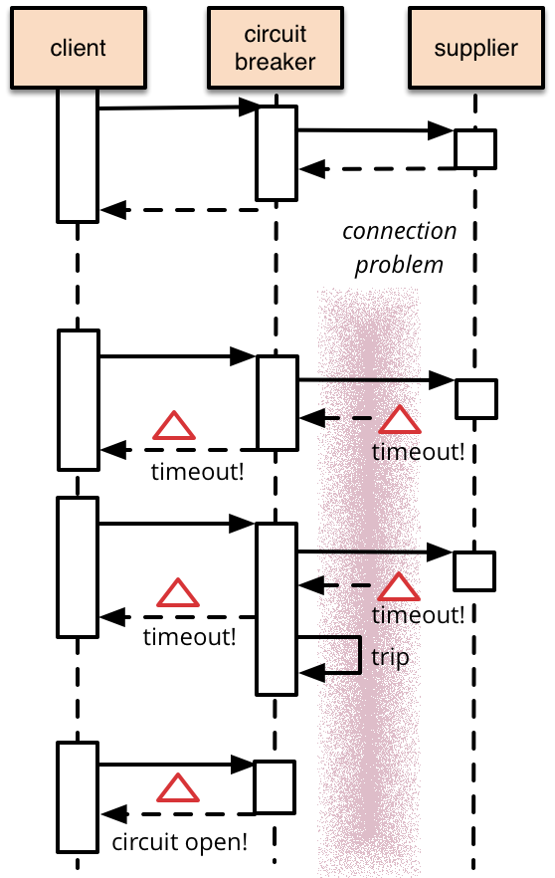

- Moleculer has a built-in circuit-breaker Solution. It is threashold-based implementation. It uses a time window to check the failed request rate. Once the threshold value is reached, It trips the circuit breaker.
- If you enable it, all service calls will be protected by the circuit breaker.
- Enable it in the broker options
const broker = new ServiceBroker(
circuitbroker : {
enabled : true,
threshold : 0.5, // 0.5 means that 50% should be failed for tripping
minRequestCount : 20,
windowTime : 60, //in seconds
halfOpenTime : 5 * 1000, // in milliseconds
check : err => err && err.code >= 500
}
});
- Global options can be overridden in action definition as well.
- Load Balacing
- Moleculer has several built-in load balancing strategies. If a service is running on multiple node instances, ServiceRegistry uses these strategies to select a single node from available ones.
- To configure strategy , set strategy broker options under registry property. It can be either a name (in case of built in strategies) or a Strategy class which inherited from BaseStrategy(in case of custom strategies).
Example :

//Moleculer.config.js
module.exports = {
registry :{
strategy : “RoundRobin”
}
};

- RoundRobin Strategy : This strategy selects node based on round-robin algorithm. Round robin is a CPU scheduling algorithm where each process is assigned a fixed slot in cyclic way.
- Random Strategy : This Strategy selects a node randomly.
- CPU Usage-based Strategy : This strategy selects a node that has lowest CPU usage. Since the node list can be very long, it gets sample and selects node with lowest CPU usage only from a sample instead of the whole list.
- Latency-based strategy : This strategy selects a node that has the lowest latency, measured by periodic ping commands. Notice that the strategy only ping one node / host. Since the node list can be very long, it gets samples and selects the host with the lowest latency only from a sample instead of the whole node list.
- Sharding Strategy : Shard invocation strategy is based on consistent-hashing algorithm. It uses a key value from context params or meta to route the request to nodes. It means that requests with same key value will be routed to the same node.

you can use set strategyOptions in registry of broker options to define ShardKey. If Shard key is in context’s meta it must be declared with a # at the begining. The actual # is ignored.
- Custom Strategy : Custom strategy can be created. We recommend to copy source of RandomStrategy and implement the select method.
Example :

const BaseStrategy = require(“moleculer”).strategies.Base;

class MyStrategy extends BaseStrategy {
select(list, ctx){/* ... */}
}

module.exports = Mystrategy;

Usage :

const {ServiceBroker} = require(“moleculer”);
const Mystrategy = require(“./my-stategy”);

// moleculer.confing.js
module.exports = {
registry : {
strategy : Mystrategy
}
};

- You can overwrite globallly defined load balancing strategy in action/event definitions.
- Api Limiter
- Winston Logging
- Why to use Winston Logging : -

- Streams: Winston uses Node.js streams, which is a performant way of chunking up data processing—for instance, data manipulation on large amounts of data. Streams break tasks down into small, manageable chunks so it’s easier for your Node.js system to handle.
- Transports: Logs need to go somewhere. By default, console.log goes to your standard output file. However, you may also want to stream your logs to a central location, or store them in a database for querying later. Winston allows you to do that easily with a concept called transports.
- Formatting: Your regular console.log, by default, only deals in strings. But Winston has some advanced features for formatting log code before stashing it away. For example, Winston offers JSON formatting, coloring log output, and the ability to fiddle with formats before they’re posted off to your end log locations.
- Levels: Winston adds another interesting layer, which is log levels. Log levels are metadata for logs. In plain English, this translates to data about data. Log levels tell you the severity, ranging from as severe as a system outage to as small as a deprecated function. The reason for having log levels in the first place is so you can quickly see which logs need attention. Log levels also allow you to configure environments to log the correct amount of data, with amounts of detail.
- To install winston : npm install winston --save
- Example :

const winston = require(‘winston’);
const logger =winston.createLogger({
transports : [
new winston.transports.console()
]
});

logger.info(‘what rolls fown stairs’);
logger.warn(“whats great for snack”);

run : node yourFileName.js

out put :
{“message” : “what rolls fown stairs”, “level” : “info”}
{“message” : “whats great for snack”, “level” : “warn”}

- The createLogger method is one th at take config object and return logger object with several method bound it which are your logging levels. That means we can use this object and the logging levels, for instance , to create our example out put.
- Winston is using JSON by Default. It is also putting our message into property(of same name) and adding a level property. This is what we want: Structured log data.
- Shorthand Configuration with default options :

// moleculer.config.js
module.exports = {
logger : “winston”,
};
- Full Configuration :

// moleculer.config.js
const winston = require("winston");
module.exports = {
logger: {
type: "Winston",
options: {
// Logging level
level: "info",
winston: {
// More settings: https://github.com/winstonjs/winston#creating-your-own-logger
transports: [
new winston.transports.Console(),
new winston.transports.File({ filename: "/logs/moleculer.log" })
]
}
}
}
};
- Communication between Different Services
- There are two types of Services
1) Local Services : Two(or more) Services running on a single node are considered local services. They share hardware resources and use local bus to communicate with each other, no network latency(Transporter is not used.
2) Remote Services : Services distributed accross multiple nodes are considered remote. In this case, the communication is done via transporter.

- Communication between nodes are done via actions and events .

Actions :

- We called actions of diffrent services via context and broker object.
- To call a service using brocker called brocker.call method. The broker looks for service(and a node) which has given action and call it. The function returns a Promise.
- Syntex: const res = await broker.call(actionName, params,opts).
- The actionName is a dot-separated string. The first part of it is the service name, while the second part of it represents the action name. So if you have a posts service with create action, you can call it as posts.create.
- The params is an object which is passed to the action as a part of the Context. The service can access it via ctx.params. It is optional. If you don’t define, It will be {}.
- The opts is an object to set/override some request parameters e.g.: timeout , retrycount. It is optional.
- Available Calling Options
Name | Type | Default | Description
timeout | Number | null | Timeout of request in milliseconds. If the request is timed out and you don’t define fallbackResponse, broker will throw a RequestTimeout error. To disable set 0. If it’s not defined, the requestTimeoutvalue from broker options will be used.
retries | Number | null | Count of retry of request. If the request is timed out, broker will try to call again. To disable set 0. If it’s not defined, the retryPolicy.retries value from broker options will be used.
fallbackResponse | Any | null | Returns it, if the request has failed.
nodeID | String | null | Target nodeID. If set, it will make a direct call to the specified node.
meta | Object | {} | Metadata of request. Access it via ctx.meta in actions handlers. It will be transferred & merged at nested calls, as well.
parentCtx | Context | null | Parent Context instance. Use it to chain the calls.
requestID | String | null | Request ID or Correlation ID. Use it for tracing.

- Examples :

Call Without Params :
const res= await broker.call(“user.list”);

Call with params :
const res = await brocker.call(“user.recommendation”,{limit : 5},
timeout : 500,
retries : 3,
fallbackResponse : defaultRecommendation
});

Call With Promise Error handling
broker.call(“posts.update”,{id:2, title:”modified post title})
.then(res => console.log(“Post Updated”)
.catch(err => console.error(“unable to update post!”,err));

Direct Call : get Health into from the node-21 node
const res = await broker.call(“$node.health”, null ,{nodeID: “node- 21”});

- Calling multiple actions at the same time is also possible. To do it use broker.mcall or ctx.mcall.

mcall with Array<Object>
await broker.call(
[
posts:{action : ‘posts.find’, params:{author : 1}, options: {}},
users:{action : ‘users.find’, params:{name : ‘john’}}
],
{
// Common calling options for all calls.
meta : { token : ‘63f20c2d-8902-4d86-ad87-b58c9e2333c2’}
}
);

mcall with Object
await broker.call(
{
posts:{action : ‘posts.find’, params:{author : 1}, options: {}},
users:{action : ‘users.find’, params:{name : ‘john’}}
},
{
// Common calling options for all calls.
meta : { token : ‘63f20c2d-8902-4d86-ad87-b58c9e2333c2’}
}
);
Events :

- Broker has a built-in event bus to support Event-driven architecture and to send events to local and remote services.
- There are two types of events.
1) Balanced Events : The Event Listners are arranged to logical groups. It means that only one listener is triggered in every group.
Example :
you have 2 main services : users & payments. Both subscribe to the user.created event. You start 3 instances of users Service and 2 instances of payments Service. When you emit user.created event, only one users and one payments service instance will receive the event.
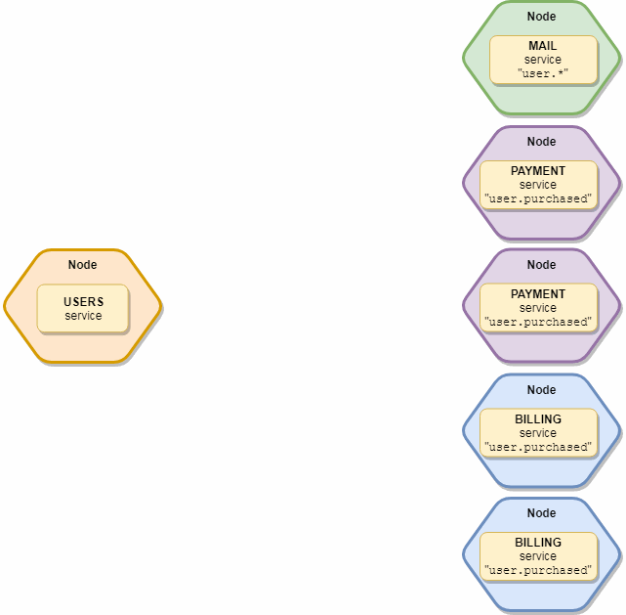

To Emit balanced Events, send Balanced events with broker.emit function. The First Parameter is the name of the event and second parameter is payload. To send multiple values, wrap into an object.
Example :

// The user will be serialized to transportation
broker.emit(“user.created”,user);

// Specify which groups/services shall receive the event
// Only the mail and payments services receive it
broker.emit(“user.created”, user, [“mail”, “payments”]);

2) Broadcast event : The Broadcast event is sent to all available local and remote services. It is not balanced, all service instances will receive it.
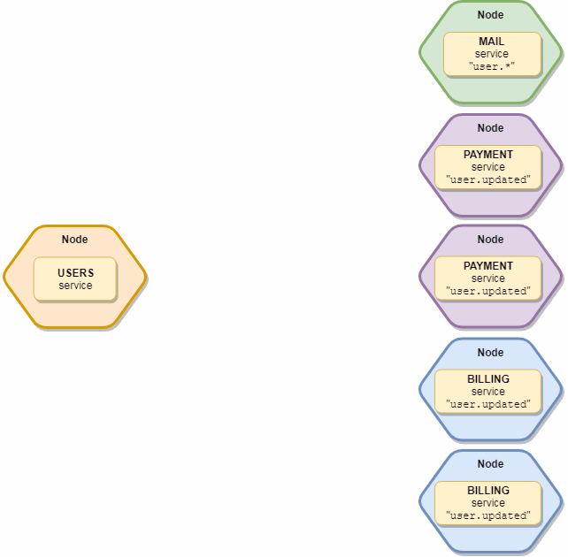
Transporters :

- In order to communicate with other remote nodes (ServiceBrokers) you need to configure a transporter. Most of the supported transporters connect to a central message broker that provide a reliable way of exchanging messages among remote nodes. These message brokers mainly support publish/subscribe messaging pattern.

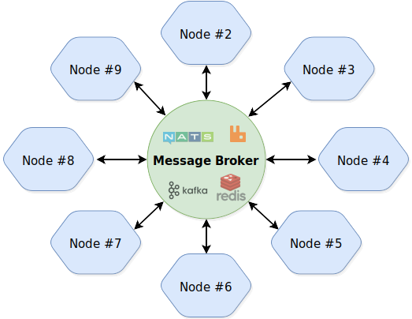

- Transporter is an important module if you are running services on multiple nodes. Transporter communicates with other nodes. It transfers events, calls requests and processes responses …etc. If multiple instances of a service are running on different nodes then the requests will be load-balanced among them.
- The whole communication logic is outside of transporter class. It means that you can switch between transporters without changing any line of code.
- There are several built-in transporters in Moleculer framework.
- For using transporters, you just need to provide configuration in moleculer.config.js.
- NATS Server is a simple, high performance open source messaging system for cloud-native applications, IoT messaging and microservices architecture.
- Example :

//moleculer.config.js
module.exports = {
nodeID:”server-1”,
transporter : “nasts://nats.server:4222”
};
- To use transporter install the nats module with npm install nats –save command.
- Examples :

Connect to ‘nats://localhost:4222’

// moleculer.config.js
module.exports = {
transporter: "NATS"
};

Connect to a remote NATS server

// moleculer.config.js
module.exports = {
transporter: "nats://nats-server:4222"
};

Connect with options

// moleculer.config.js
module.exports = {
transporter: {
type: "NATS",
options: {
url: "nats://localhost:4222"
user: "admin",
pass: "1234"
}
}
};

Connect with TLS

// moleculer.config.js
module.exports = {
transporter: {
type: "NATS",
options: {
url: "nats://localhost:4222"
// More info: https://github.com/nats-io/node-nats#tls
tls: {
key: fs.readFileSync('./client-key.pem'),
cert: fs.readFileSync('./client-cert.pem'),
ca: [ fs.readFileSync('./ca.pem') ]
}
}
}
};

- Implement Custom MiddleWares
- Moleculer suppots middlewares. Its same as plugins in other fameworks. The middleware is an object with hooks and wrapper functions. It Allows to wrap action handlers, event handlers, broker methods and hook life cycle events.
- Example :

module.exports = {
name : “awesome”,

localAction(next, action) {
return function(ctx) {
console.log(`mY Middlewares is called before the `$ {ctx.action.name}` action executed . `);
return next(ctx);
}
}
};

- If you want to use built-in middlewares use their names in middlewares[] broker option. Also the middlewares can be easily extended with custom functions.
- Load middleware by name
- Example :

// moleculer.config.js
const { Middlewares } = require("moleculer");
// Extend with custom middleware
Middlewares.MyCustom = {
created(broker) {
broker.logger.info("My custom middleware is created!");
}
};

// Brocker File
const { Middlewares } = require("moleculer");

module.exports = {
logger: true,
middlewares: [
// Load middleware by name
"MyCustom"
]
};

- Error Handling
- The global handler is generic way to handle exceptions. It caches the unhandled errors of cation and event handlers.
- Catch, handle, log and Throw error

const broker = new ServiceBroker({
errorHandler(err,info){ // handle the error
this.logger.warn(“error handled : “,err);
throw err ; //Throw further
}});
- you can also define route level and global level custom error handlers. In handlers, you must call the res.end. Otherwise, the request is unhandled.

broker.createService({
mixins: [ApiService],
settings: {
routes: [{
path: "/api",
// Route error handler
onError(req, res, err) {
res.setHeader("Content-Type", "application/json; charset=utf-8");
res.writeHead(500);
res.end(JSON.stringify(err));
}
}],
// Global error handler
onError(req, res, err) {
res.setHeader("Content-Type", "text/plain");
res.writeHead(501);
res.end("Global error: " + err.message);
}
}
}

- Timeout Handling
- For handling Timeout, we have to configure Timeout Setting in broker Options, Action Options or calling options .
- Moleculer Service Broker has options called Request Timeout.
- Request Timeout means Number of miliseconds to wait before reject a request with a Request Timeout Error.
- Default value for Request timeout is 0 means it is disabled.
- We can also set timeout value while calling action as well using timeout options .
- Its default value is null.
- Timeout option set Timeout of request in miliseconds. If the request is timed out and you dont define fallbackresponse, Broker will throw RequestTimeout error. To disable set 0. If it is not defined , broker options will be used.
- If it is set, it will overwrites broker options and action options timeout setting.
- Timeout can be set in action definition as well .
- It overwrites the global broker requestTimeout option, but not the timeout in calling options.
- Moleculer uses distributed timeouts. In case of nested calls, the timeout value is decremented with the elapsed time. If the timeout value is less or equal than 0, the next nested calls will be skipped (RequestSkippedError) because the first call has already been rejected with a RequestTimeoutError error.

